Elevate Your
LinkedIn Profile

Your LinkedIn profile is often part of a first impression with clients, prospective clients, and professional advisors. A complete, current profile makes it easier for them to understand your role, your areas of focus, and the experience you bring to a conversation. Here are a few things to review:
Give your profile a refresh
• Photo and background. Use a current, professional headshot and an approved, relevant background image.

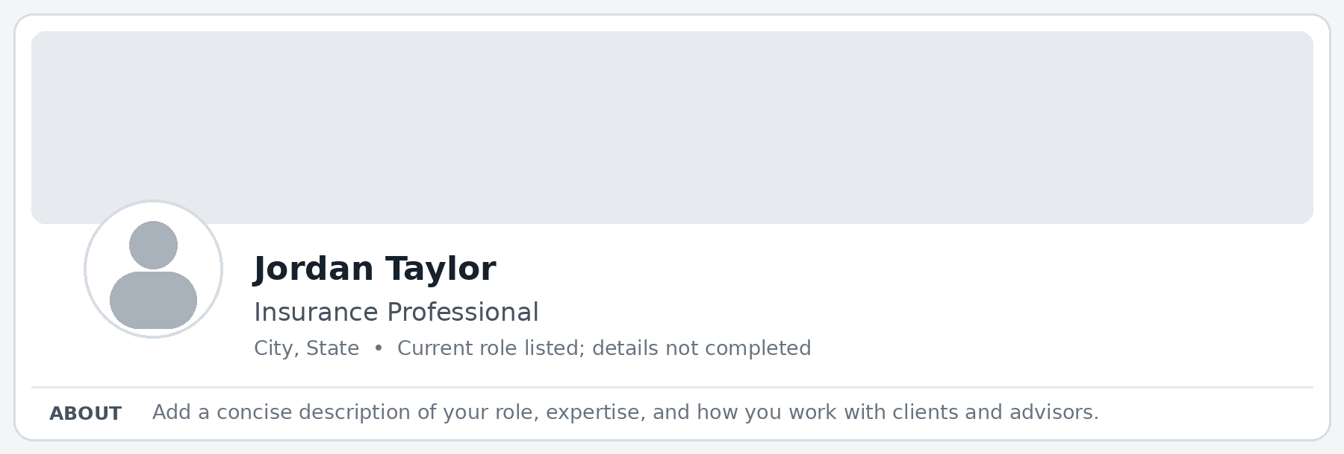
Example: a generic profile with a blank background, placeholder photo, and unfinished About section.

• Headline. Make your role and area of focus clear in language a client or advisor will understand. Avoid unsupported superlatives or claims.
• About section. Write in your own voice. Explain who you work with, the topics you handle, and how you collaborate. Keep it factual and client-centered.
• Experience and credentials. Update your current role, dates, descriptions, and credentials. Include only accurate, approved information.
• Featured and contact details. Use appropriate, approved materials and make sure the contact information you want to share is current.

Use AI to help
The prompts below show how to give AI clear direction. A complete prompt tells it what role to take, who the audience is, what the content should accomplish, what information to use, and what to produce.

Elevate Your
LinkedIn Profile

How to use:
Copy a prompt into your Alliant ChatGPT Enterprise platform and replace the bracketed text with accurate, nonconfidential information. You can adjust the audience, goal, tone, and output to fit your needs.
- Protect information: Do not enter client names, account details, claims information, or other confidential or nonpublic material.
- Review before using: You are responsible for checking the content for accuracy, keeping your own voice, and following Alliant’s social media policy and applicable review requirements before changing your profile or publishing content.

Prompt 1 — Evaluate and improve your bio
Act as a professional LinkedIn editor helping a HNW insurance producer communicate clearly with clients and professional advisors.

Review my LinkedIn About section for [clarity, completeness, accuracy, or another priority]. My intended audience is [describe the clients or professional advisors you want to reach]. My goal is to help them understand [your role, areas of focus, or how you work with them].
Use these verified details: [add your role, experience, areas of expertise, and approach]. Here is my current About section: [paste your bio].

First, identify what is clear and what may be missing, vague, repetitive, or outdated. Then draft a concise revision in first person, using a professional and approachable tone. Do not invent credentials, experience, client examples, or results. Flag any facts I should verify.

Prompt 2 — Write a post about a misconception

Draft a response for [intended audience] to this question I recently received: [paste a generalized question without names or identifying details]. The goal is to [clarify a concept, share a consideration, or suggest an appropriate next step].

My role and relevant expertise are [describe them]. Use these verified points: [add approved information]. Keep the response [brief, conversational, educational] and within my area of expertise.

Do not assume facts that are not in the question, disclose client information, promise coverage or outcomes, or provide legal, tax, or other advice outside my role. Draft one response and flag anything that needs verification or review.

